**Model Development Phase Report**

|  |  |
| --- | --- |
| Date | June 2025 |
| Team ID | SWTID1749841176 |
| Project Title | Online Payments Fraud Detection Using Machine Learning |
| Maximum Marks | 4 Marks |

**Initial Model Training Code, Model Validation and Evaluation Report**

The initial model training code will be showcased in the future through a screenshot. The model validation and evaluation report will include classification reports, accuracy, and confusion matrices for multiple models, presented through respective screenshots.

**Initial Model Training Code:**

**Note:** For ease of working with the data and for model training we have used a label encoder to encode the string values

1. **“is Fraud” as 1**
2. **“is not Fraud” as 0**

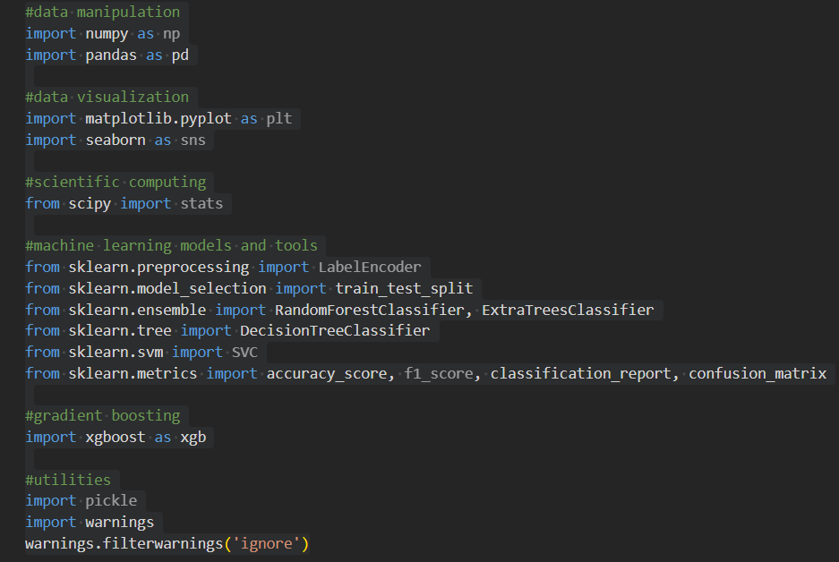

**Random Forest Classifier:**

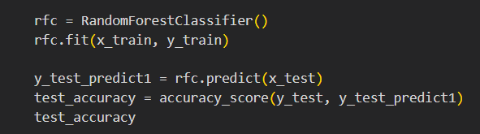

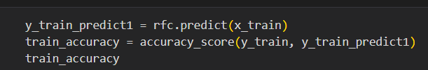

**Decision Tree Classifier:**

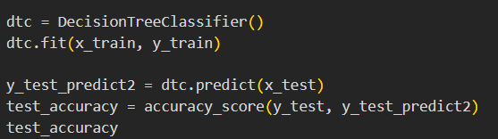

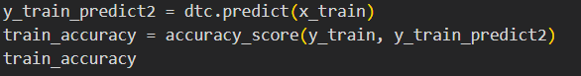

**Extra Trees Classifier:**

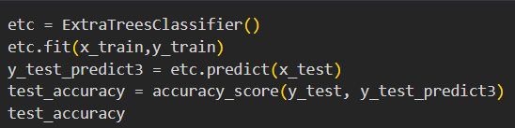

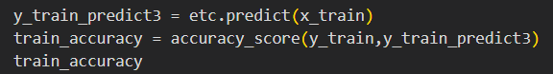

**SupportVectorMachine Classifier:**

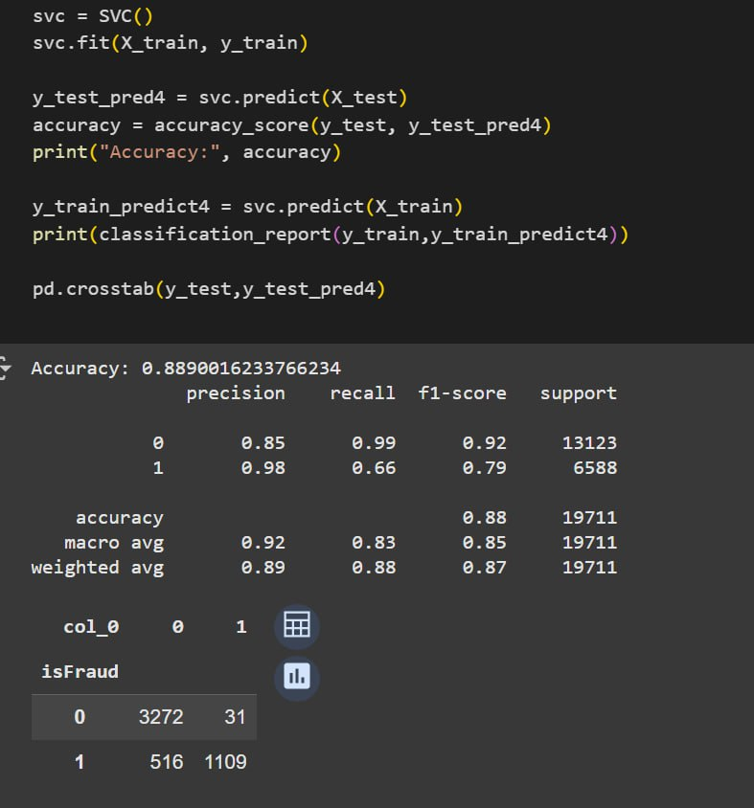

**XgBoost Classifier:**

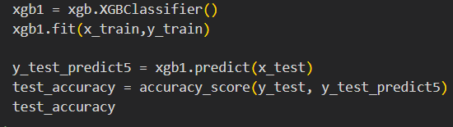

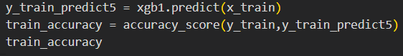

**Model Validation and Evaluation Report:**

|  |  |  |  |
| --- | --- | --- | --- |
| **Model** | **Classification Report** | **F1 Score** | **Confusion Matrix** |
| Random Forest Classifier |  | 94% |  |
| Decision Tree Classifier |  | 94% |  |
| Extra Trees Classifier |  | 93% |  |
| Support Vector Machine Classifier |  | 85% |  |
| XgBoost Classifier |  | 91% |  |